Project 24.3 Jason Lorenz

1. A screenshot of a computer

   Description automatically generated with medium confidence
2. A screenshot of a computer

   Description automatically generated
3. A screenshot of a computer

   Description automatically generated
4. 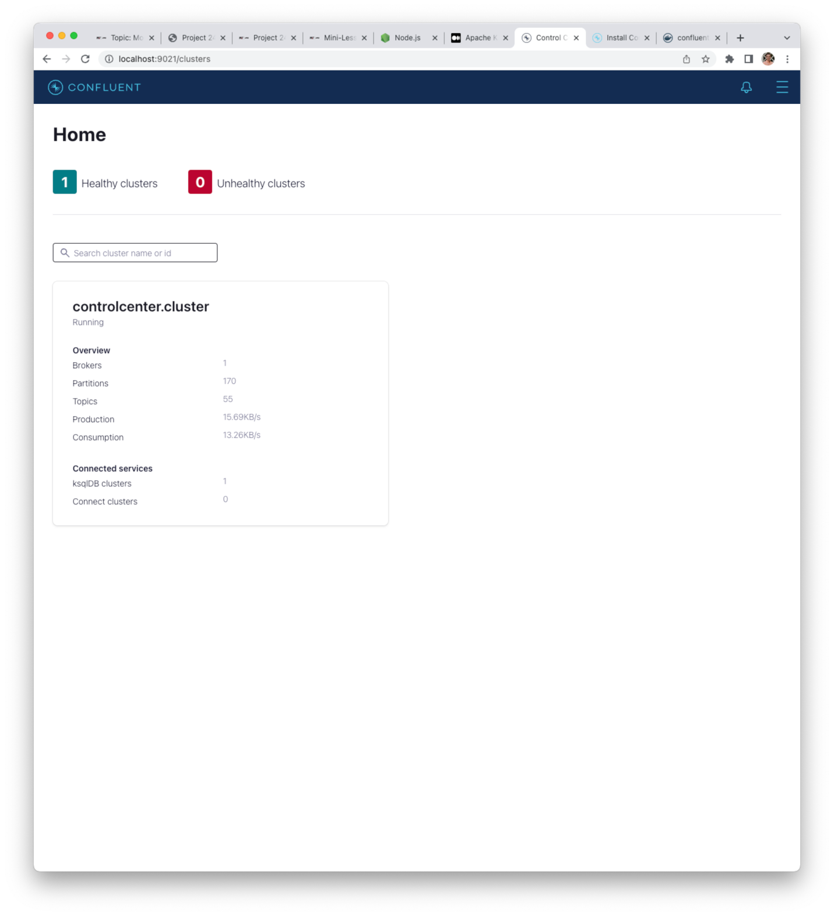
5. A screenshot of a computer

   Description automatically generated
6. 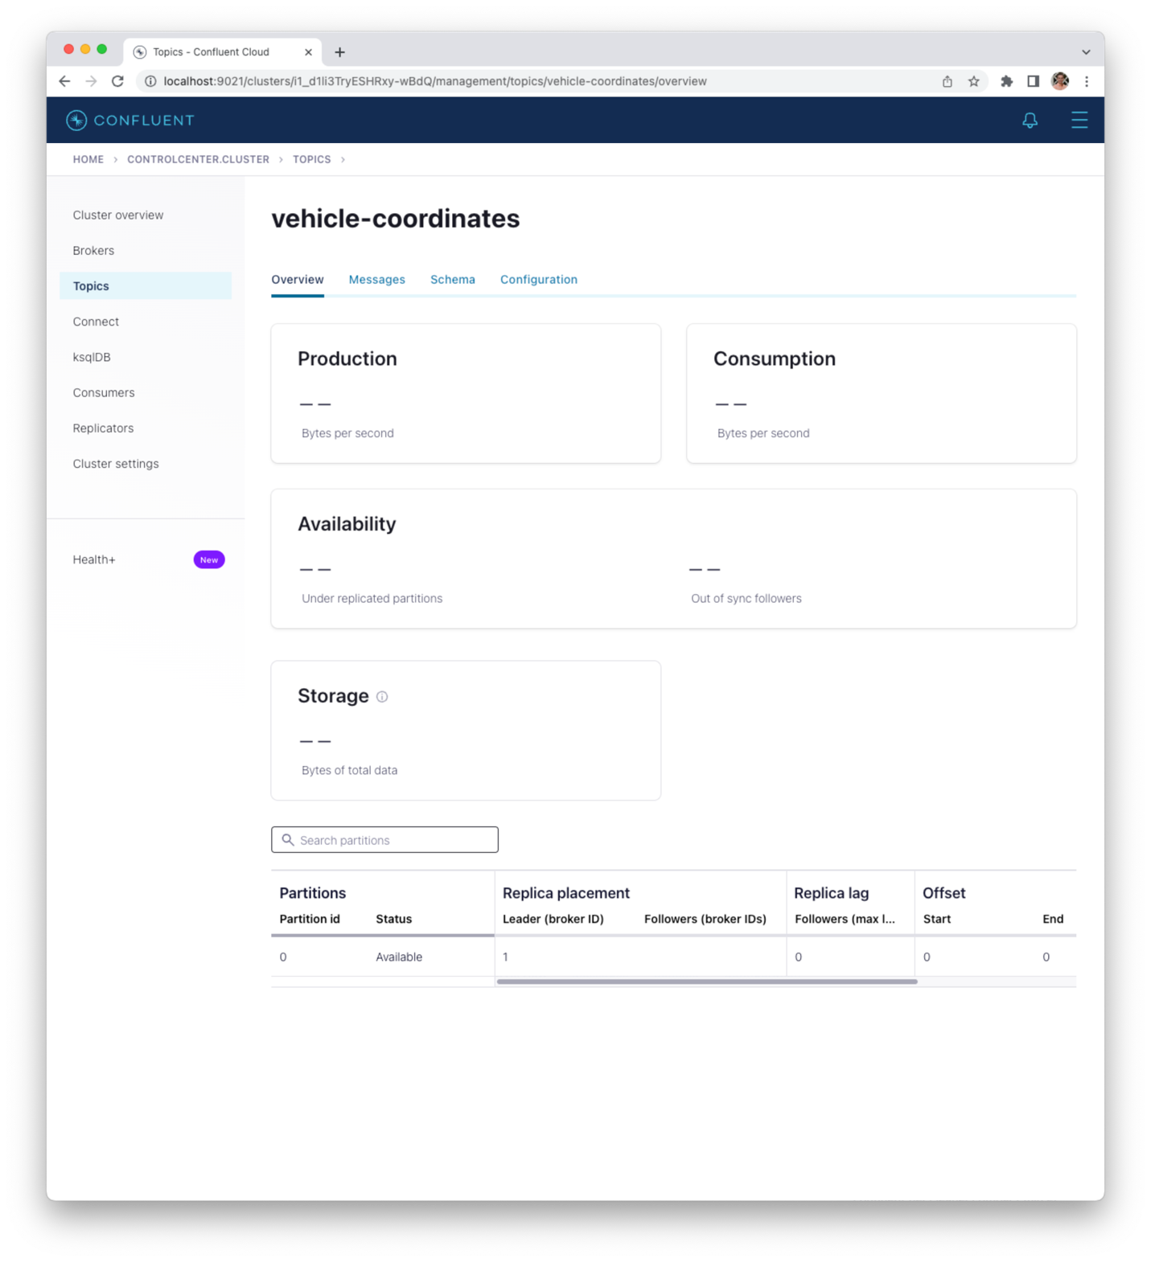
7. 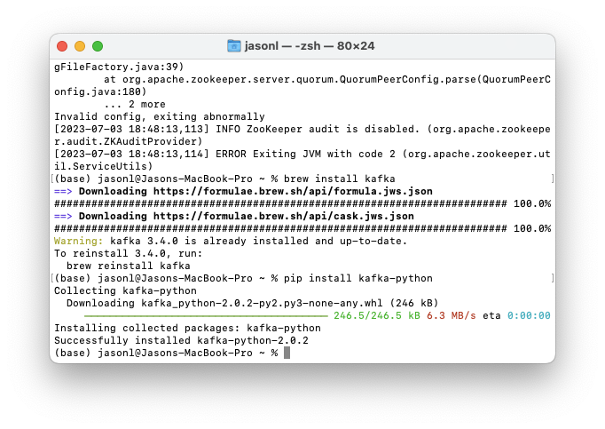
8. 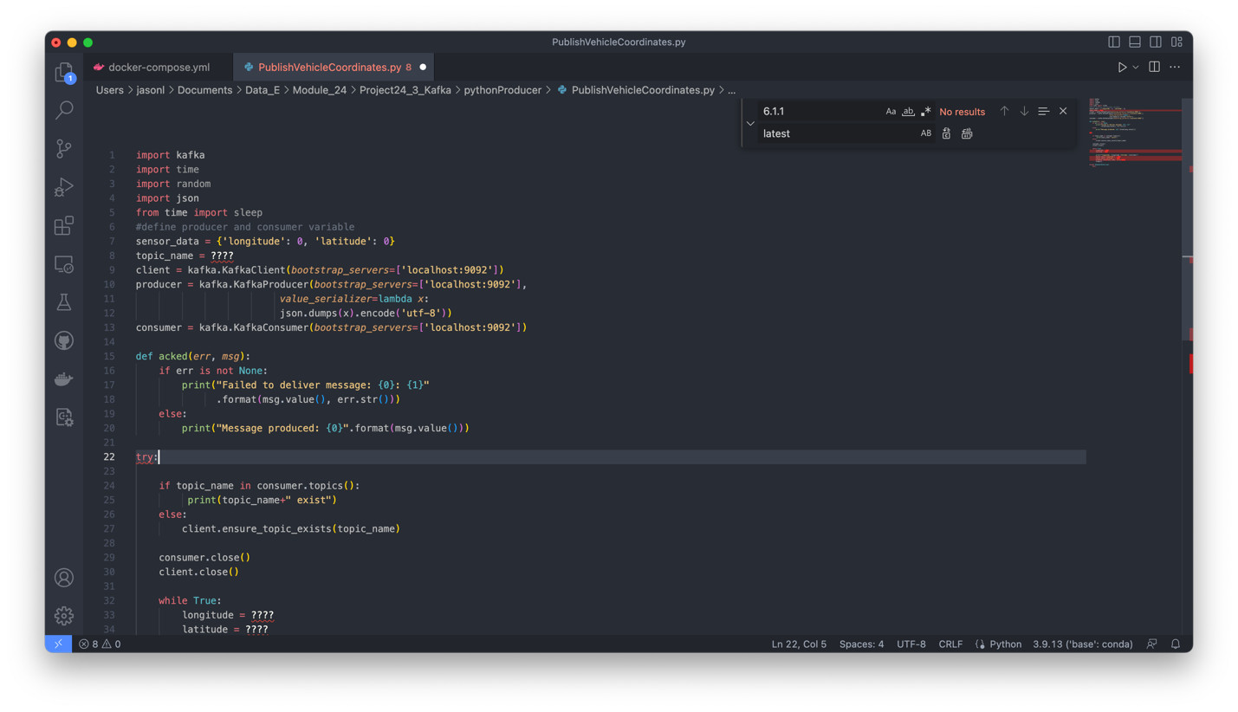
9. A screenshot of a computer

   Description automatically generated
10. A screenshot of a computer

    Description automatically generated with medium confidence
11. A screenshot of a computer

    Description automatically generated with medium confidence
12. A screenshot of a computer

    Description automatically generated with medium confidence
13. A screenshot of a computer

    Description automatically generated with medium confidence
14. A screenshot of a computer

    Description automatically generated with medium confidence
15. A screenshot of a computer

    Description automatically generated
16. A screenshot of a computer

    Description automatically generated